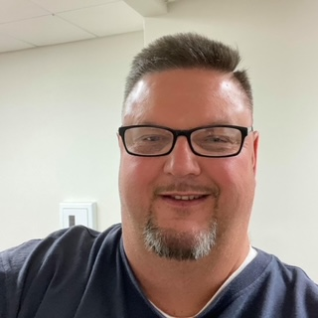**The Challenge (Background):**

After years of working at Timken in Gaffney, William was facing a layoff and weary about the next chapter of his life. William had concerns as he did not complete high school and knew that he needed to obtain a GED to further his career. He attended a Rapid Response Session hosted at Timken and learned about the variety of services available to him as a Dislocated Worker. He made the decision visit the SC Works Gaffney Center and talked with Yolanda Reid; a local Talent Development Specialist housed there.

**The Solution (WIOA Services):**

During the initial visit, he shared that he had already been enrolled with Adult Education to work on obtaining a GED but wanted more information about training services upon completion. William was enrolled into the WIOA program on 08/10/2023 and quickly completed the program requirements. He made the decision to pursue CDL training and chose to attend 160 Driving Academy; he began training on 8/22/2023.

**The Outcome:**

William simultaneously attended GED training and CDL training, and successfully completed both programs, obtaining his GED and Commercial Driver’s License. He completed CDL training on 11/20/2023. William exemplified perseverance and a strong desire to create a better life for himself! He secured employment with MSI, starting on 1/22/2024 as a Truck Driver living out the dream!